Project Management Support
Job pack
This pack contains the following sections:
- How to apply
- Role description and Person Specification

About the employer:
About H4All:

H4All is a formal collaborative of five voluntary sector organisations in the London Borough of Hillingdon that is being widely recognised for its innovation and new ways of working. H4All combines the expertise of its member organisations and the wider voluntary sector to bring health benefits to Hillingdon residents.
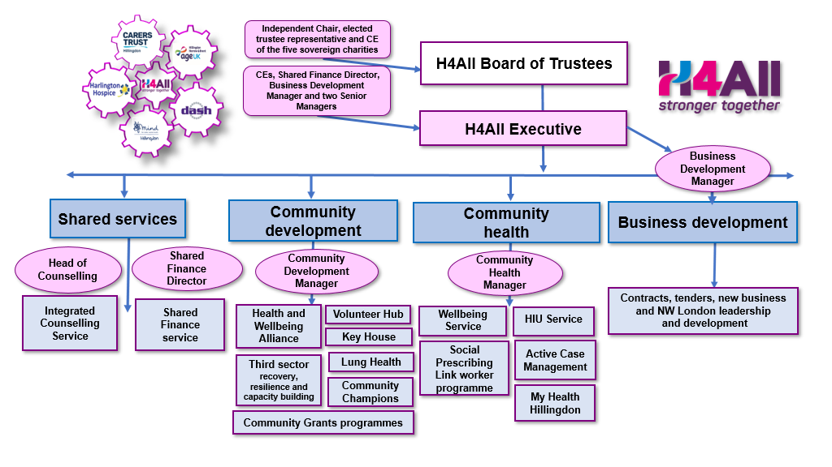

H4All CIO is a partner in the local Hillingdon Health and Care Partnership (HHCP) which includes the Hillingdon Primary Care Confederation as well as the local NHS foundation trusts providing community care services and acute hospital care.

https://www.h4all.org.uk/

Working with our partners in North West London, H4All has been instrumental in creating:

3ST – Third Sector Together – is a group of like-minded larger charities that have been working together since 2019 across the eight boroughs of NW London: Harrow, Hillingdon, Brent, Hounslow, Ealing, Hammersmith and Fulham, Kensington and Chelsea and Westminster.

https://www.3stnwl.org.uk/

How to apply

Candidates are invited to email the contact provided and an application form will be emailed to you for completion and return. Alternatively, please visit our web site at: https://www.h4all.org.uk/current-vacancies

Candidates are advised to structure their supporting statement in line with the points in the person specification, and to provide clear examples of their experience that demonstrate their skills and knowledge.
Candidates are warmly invited to arrange an informal discussion with the recruiting manager, before submitting their application, which can be arranged by contacting Fiona Hill at:fhill@h4all.org.uk

Closing date for applications: 28th January 2022

The Role:
Project Management Support

Hours: 35 hours per week, Monday to Friday
Contract: 1-year Fixed term Contract with potential to extend
Salary: £29,000 per annum

Project Management Support

Role Purpose
Responsible to: Business Development Manager

Based at: H4All head office, Key House, 106 High Street Yiewsley, UB7 7BQ. Flexible and home working options are available to all staff subject to negotiation and service need

Main purpose of the job:

The main purpose of this role is to support H4All and partners with timely, efficient and effective delivery of projects to enable a smooth transition to operational delivery, this will include the mobilisation of new services.

Key relationships: H4All Partner organisations including 3ST partners; Primary Care Networks; Hillingdon Health and Social Care Partners; ICS; Local authorities; H4All teams; local residents and; Third Sector partners.

Main duties and responsibilities (role profile)

Main duties

- Support H4All, and partner organisations with timely, efficient and effective delivery of health and wellbeing projects.
- Provide support to develop project plans and to take the day-to-day lead on agreed workstreams including undertake specific task and actions to enable the delivery of key milestones within a variety of workstreams and projects
- To work proactively under own initiative to ensure the delivery of project milestones.
- Create and maintain project documentation including risk registers.
- To track and report progress and performance of a number of projects and tasks, presenting at meetings as required.
- To engage with stakeholders to support project outcomes and timelines
- To support mobilisation of new services, working closely with operational teams to ensure smooth transition to operational stage.
- To support Business Development Manager in project development.
- To lead working groups with key stakeholders.

General Duties
- To be pro-active in maintaining personal and professional learning and development and identify own training needs as they arise.
- To attend team meetings, away days and other similar events
- To participate fully in regular one-to-one supervision sessions and in an annual performance appraisal
- Work as part of the team to seek feedback, continually improve the service and contribute to business planning. Undertake any tasks consistent with the level of the post and the scope of the role, ensuring that work is delivered in a timely and effective manner.
- Ensure compliance with all relevant policies and procedures in relation to health and safety, equal opportunities, safeguarding, lone working, customer service, data protection and confidentiality.
- Work within H4All policies and procedures including Equality and Diversity, Health & Safety, Confidentiality, Data Security, Lone Working and Safeguarding.
- Undertake other general duties as may be deemed necessary that are consistent with the level of the post and scope of the work in a timely and effective manner
- Participate H4All, and partner project events including occasional weekend and evening activity and proactively support service delivery across the organisation

Person Specification

Education/qualifications

 | Essential criteria | Desirable criteria
1 | Qualifications at degree level through formal qualification or equivalent experience | A project management qualification
Experience

 | Essential criteria | Desirable criteria
2 | Engagement skills, an ability to promote projects, encourage referrals and highlight project benefits to a wide audience | Experience of project delivery as part of a project management team
3 | Experience of working with a variety of stakeholders to bring about change and service developments. | Experience of working with statutory sector stakeholders.
4 | Previous experience of working within operational delivery of community-based services | An appreciation and understanding of issues facing the statutory providers at local level and how the Third Sector can support.
Knowledge and understanding

 | Essential criteria | Desirable criteria
5 | Knowledge and understanding of the principles of project delivery
6 | Partnership working – building effective relationships with different groups (internal and external) and partner agencies/ organisations.
7 | Ability to build good working relationships with a range of stakeholders | Knowledge of the voluntary sector and facilities in the London Borough of Hillingdon.
8 | An ‘ideas’ person that can find creative solutions to problems, or barriers to engagement | Persuasive and able to use knowledge to influence others
Skills and abilities

 | Essential criteria | Desirable criteria
9 | Strong communication skills and ability to communicate with a wide range of stakeholders | Influencing and negotiation skills
10 | A strong team player but able to work alone and self-motivate as required
11 | An ability to adopt an analytical and methodical approach to problem solving | Co-ordinate and arrange consultation events, facilitate groups and report on the findings of consultation work
12 | Proficient IT and social media skills, for example, able to send and receive email messages, upload information onto a website, create documents such as agendas, use social media to communicate with stakeholders | Working as part of a ‘dispersed’ or ‘virtual’ team  Experience of establishing and reporting to management team/board/steering committee.
13 | Ability to present information logically to support action plans and programme objectives | Demonstrated ability to analyse situations and to provide a resolution
14 | Excellent IT skills, including all Microsoft office programmes | Understanding of developing project budgets.
15 | Ability to analyse information and present analysis | Ability to produce clear and accessible reports
Personal Attributes
 | Essential Criteria | Desirable Criteria
16 | Ability to use own initiative within sphere of responsibility | Self-motivated and resilient.  Actively develops themselves
17 | Demonstrated ability at exercising tact and diplomacy

